PT Activity 2.5.2: Challenge PPP Configuration (Solution)

Topology

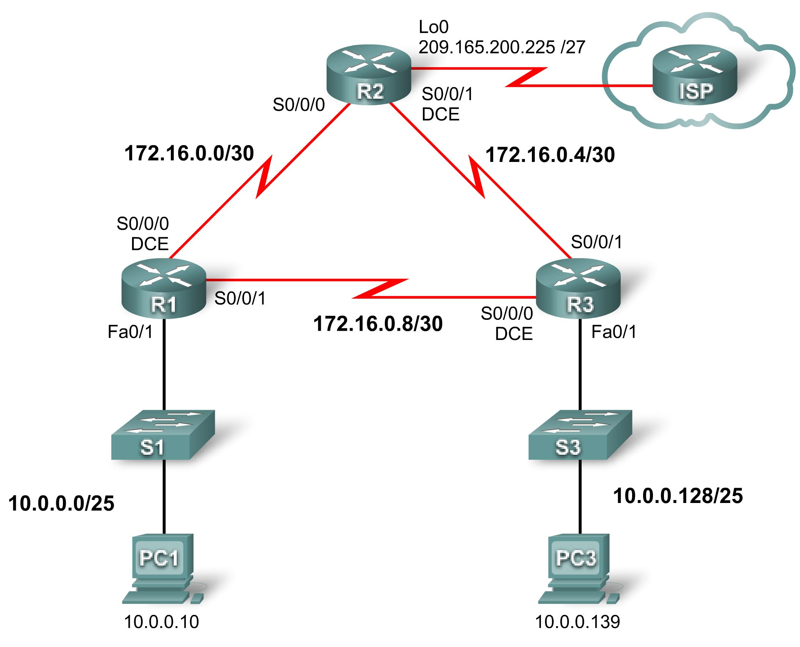

Addressing Table
Device | Interface | IP Address | Subnet Mask | Default Gateway
R1 | Fa0/1 | 10.0.0.1 | 255.255.255.128 | N/A
R1 | S0/0/0 | 172.16.0.1 | 255.255.255.252 | N/A
R1 | S0/0/1 | 172.16.0.9 | 255.255.255.252 | N/A
R2 | Lo0 | 209.165.200.161 | 255.255.255.224 | N/A
R2 | S0/0/0 | 172.16.0.2 | 255.255.255.252 | N/A
R2 | S0/0/1 | 172.16.0.5 | 255.255.255.252 | N/A
R3 | Fa0/1 | 10.0.0.129 | 255.255.255.128 | N/A
R3 | S0/0/0 | 172.16.0.10 | 255.255.255.252 | N/A
R3 | S0/0/1 | 172.16.0.6 | 255.255.255.252 | N/A
PC1 | NIC | 10.0.0.10 | 255.255.255.128 | 10.0.0.1
PC3 | NIC | 10.0.0.139 | 255.255.255.128 | 10.0.0.129

Learning Objectives
- Configure and activate interfaces.
- Configure OSPF routing on all routers.
- Configure PPP encapsulation on all serial interfaces.
- Configure PPP CHAP authentication.

Introduction
In this activity, you will configure PPP encapsulation on serial links using the network shown in the topology diagram. You will also configure PPP CHAP authentication. If you need assistance, refer back to the Basic PPP Configuration lab or activity, but try to do as much on your own as possible.
Task 1: Configure and Activate Serial and Ethernet Addresses
Step 1. Configure interfaces on R1, R2, and R3.
The addressing scheme is listed on the topology and in the Addressing Table. Some interface addresses are provided, but for some interfaces only the network is provided. In the cases where you are only given the network address, you may use any valid address on the specified network in order to be graded correctly in Packet Tracer.
Configure the interfaces for R1, R2, and R3 according to the topology. On the DCE sides of the serial links, the clock rate is 64000 bits.
R1
!
interface FastEthernet0/1
ip address 10.0.0.1 255.255.255.128
no shutdown
!

interface Serial0/0/0
ip address 172.16.0.1 255.255.255.252
no shutdown
clock rate 64000
!
interface Serial0/0/1
ip address 172.16.0.9 255.255.255.252
no shutdown

R2
!
interface Loopback0
ip address 209.165.200.161 255.255.255.224
!
!
interface Serial0/0/0
ip address 172.16.0.2 255.255.255.252
no shutdown
!
interface Serial0/0/1
ip address 172.16.0.5 255.255.255.252
clock rate 64000
no shutdown

R3
!
interface FastEthernet0/1
ip address 10.0.0.129 255.255.255.128
no shutdown
!
interface Serial0/0/0
ip address 172.16.0.10 255.255.255.252
clock rate 64000
no shutdown
!
interface Serial0/0/1
ip address 172.16.0.6 255.255.255.252
no shutdown
Step 2. Verify IP addressing and interfaces.
Verify that all the interfaces are up at both the physical and data link layers. Directly connected routers should be able to ping each other.
R1#show ip interface brief
Interface IP-Address OK? Method Status Protocol
FastEthernet0/0 unassigned YES manual administratively down down
FastEthernet0/1 10.0.0.1 YES manual up up
Serial0/0/0 172.16.0.1 YES manual up up
Serial0/0/1 172.16.0.9 YES manual up up

R2#show ip interface brief
Interface IP-Address OK? Method Status Protocol
FastEthernet0/0 unassigned YES unset administratively down down
FastEthernet0/1 unassigned YES unset administratively down down
Serial0/0/0 172.16.0.2 YES manual up up
Serial0/0/1 172.16.0.5 YES manual up up
Loopback0 209.165.200.161 YES manual up up

R3#show ip interface brief
Interface IP-Address OK? Method Status Protocol
FastEthernet0/0 unassigned YES unset administratively down down
FastEthernet0/1 10.0.0.129 YES manual up up
Serial0/0/0 172.16.0.10 YES manual up up
Serial0/0/1 172.16.0.6 YES manual up up
Step 3. Configure the Ethernet interfaces of PC1 and PC3.
For PC1, use any IP address between 10.0.0.2 and 10.0.0.126. For PC3, use any IP address between 10.0.0.128 and 10.0.0.254.
Step 4. Test connectivity between the PCs.
Should the PCs be able to ping each other at this point? Can they ping their default gateways?
Task 2: Configure OSPF on Routers
Step 1. Enable OSPF routing on the routers.
When configuring OSPF routing, use a process ID of 1.
R1
!
router ospf 1
network 10.0.0.0 0.0.0.127 area 0
network 172.16.0.0 0.0.0.3 area 0
network 172.16.0.8 0.0.0.3 area 0
!
R2
!
router ospf 1
network 172.16.0.0 0.0.0.3 area 0
network 172.16.0.4 0.0.0.3 area 0
network 209.165.200.160 0.0.0.31 area 0
!
R3
!
router ospf 1
network 10.0.0.128 0.0.0.127 area 0
network 172.16.0.4 0.0.0.3 area 0
network 172.16.0.8 0.0.0.3 area 0
!
Step 2. Verify that you have full network connectivity.
All routers should have routes to all networks and now be able to ping any device.
R1#show ip route

<output omitted>

172.16.0.0/30 is subnetted, 3 subnets
C 172.16.0.8 is directly connected, Serial0/0/1
O 172.16.0.4 [110/1562] via 172.16.0.10, 00:09:11, Serial0/0/1
[110/1562] via 172.16.0.2, 00:09:11, Serial0/0/0
C 172.16.0.0 is directly connected, Serial0/0/0
209.165.200.0/32 is subnetted, 1 subnets
O 209.165.200.161 [110/782] via 172.16.0.2, 00:09:11, Serial0/0/0
10.0.0.0/25 is subnetted, 2 subnets
C 10.0.0.0 is directly connected, FastEthernet0/1
O 10.0.0.128 [110/782] via 172.16.0.10, 00:09:11, Serial0/0/1

R1#ping 209.165.200.161

Type escape sequence to abort.
Sending 5, 100-byte ICMP Echos to 209.165.200.161, timeout is 2 seconds:
!!!!!
Success rate is 100 percent (5/5), round-trip min/avg/max = 28/28/28 ms
R1#ping 10.0.0.129

Type escape sequence to abort.
Sending 5, 100-byte ICMP Echos to 10.0.0.129, timeout is 2 seconds:
!!!!!
Success rate is 100 percent (5/5), round-trip min/avg/max = 28/28/28 ms
R2#show ip route

<output omitted>

172.16.0.0/30 is subnetted, 3 subnets
O 172.16.0.8 [110/1562] via 172.16.0.6, 00:12:42, Serial0/0/1
[110/1562] via 172.16.0.1, 00:12:42, Serial0/0/0
C 172.16.0.4 is directly connected, Serial0/0/1
C 172.16.0.0 is directly connected, Serial0/0/0
209.165.200.0/27 is subnetted, 1 subnets
C 209.165.200.160 is directly connected, Loopback0
10.0.0.0/25 is subnetted, 2 subnets
O 10.0.0.0 [110/782] via 172.16.0.1, 00:12:42, Serial0/0/0
O 10.0.0.128 [110/782] via 172.16.0.6, 00:12:42, Serial0/0/1

R2#ping 10.0.0.1

Type escape sequence to abort.
Sending 5, 100-byte ICMP Echos to 10.0.0.1, timeout is 2 seconds:
!!!!!
Success rate is 100 percent (5/5), round-trip min/avg/max = 28/28/28 ms
R2#ping 10.0.0.129

Type escape sequence to abort.
Sending 5, 100-byte ICMP Echos to 10.0.0.129, timeout is 2 seconds:
!!!!!
Success rate is 100 percent (5/5), round-trip min/avg/max = 28/28/32 ms

R3#show ip route

<output omitted>

172.16.0.0/30 is subnetted, 3 subnets
C 172.16.0.8 is directly connected, Serial0/0/0
C 172.16.0.4 is directly connected, Serial0/0/1
O 172.16.0.0 [110/1562] via 172.16.0.9, 00:14:14, Serial0/0/0
[110/1562] via 172.16.0.5, 00:14:14, Serial0/0/1
209.165.200.0/32 is subnetted, 1 subnets
O 209.165.200.161 [110/782] via 172.16.0.5, 00:14:14, Serial0/0/1
10.0.0.0/25 is subnetted, 2 subnets
O 10.0.0.0 [110/782] via 172.16.0.9, 00:14:14, Serial0/0/0
C 10.0.0.128 is directly connected, FastEthernet0/1

R3#ping 209.165.200.161

Type escape sequence to abort.
Sending 5, 100-byte ICMP Echos to 209.165.200.161, timeout is 2 seconds:
!!!!!
Success rate is 100 percent (5/5), round-trip min/avg/max = 28/28/28 ms
R3#ping 10.0.0.1

Type escape sequence to abort.
Sending 5, 100-byte ICMP Echos to 10.0.0.1, timeout is 2 seconds:
!!!!!
Success rate is 100 percent (5/5), round-trip min/avg/max = 28/28/32 ms
Task 3: Configure PPP Encapsulation on Serial Interfaces
Step 1. Configure PPP on the serial interfaces of all three routers.
Currently encapsulation is set to HDLC on all the serial links. In order to configure authentication later, encapsulation must be set to PPP.
R1

interface Serial0/0/0
encapsulation ppp
!
interface Serial0/0/1
encapsulation ppp

R2

interface Serial0/0/0
encapsulation ppp
!
interface Serial0/0/1
encapsulation ppp

R3

interface Serial0/0/0
encapsulation ppp
!
interface Serial0/0/1
encapsulation ppp
Step 2. Verify that all serial interfaces are using PPP encapsulation.
If connected serial interfaces have mismatched encapsulation, the link will go down. Make sure all interfaces are set to PPP encapsulation.
R1#show interface serial0/0/0
Serial0/0/0 is up, line protocol is up
Hardware is GT96K Serial
Internet address is 172.16.0.1/30
MTU 1500 bytes, BW 128 Kbit, DLY 20000 usec,
reliability 255/255, txload 1/255, rxload 1/255
Encapsulation PPP, LCP Open
Open: CDPCP, IPCP, loopback not set

R1#show interface serial0/0/1
Serial0/0/1 is up, line protocol is up
Hardware is GT96K Serial
Internet address is 172.16.0.9/30
MTU 1500 bytes, BW 128 Kbit, DLY 20000 usec,
reliability 255/255, txload 1/255, rxload 1/255
Encapsulation PPP, LCP Open
Open: CDPCP, IPCP, loopback not set

R2

R2#show interface serial0/0/0
Serial0/0/0 is up, line protocol is up
Hardware is GT96K Serial
Internet address is 172.16.0.2/30
MTU 1500 bytes, BW 128 Kbit, DLY 20000 usec,
reliability 255/255, txload 1/255, rxload 1/255
Encapsulation PPP, LCP Open
Open: CDPCP, IPCP, loopback not set

R2#show interface serial0/0/1
Serial0/0/1 is up, line protocol is up
Hardware is GT96K Serial
Internet address is 172.16.0.5/30
MTU 1500 bytes, BW 128 Kbit, DLY 20000 usec,
reliability 255/255, txload 1/255, rxload 1/255
Encapsulation PPP, LCP Open
Open: CDPCP, IPCP, loopback not set

R3

R3#show interface serial0/0/0
Serial0/0/0 is up, line protocol is up
Hardware is GT96K Serial
Internet address is 172.16.0.10/30
MTU 1500 bytes, BW 128 Kbit, DLY 20000 usec,
reliability 255/255, txload 1/255, rxload 1/255
Encapsulation PPP, LCP Open
Open: CDPCP, IPCP, loopback not set

R3#show interface serial0/0/1
Serial0/0/1 is up, line protocol is up
Hardware is GT96K Serial
Internet address is 172.16.0.6/30
MTU 1500 bytes, BW 128 Kbit, DLY 20000 usec,
reliability 255/255, txload 1/255, rxload 1/255
Encapsulation PPP, LCP Open
Open: CDPCP, IPCP, loopback not set
Task 4: Configure PPP CHAP Authentication
The password for CHAP authentication is cisco.
Step 1. Configure PPP CHAP authentication on all serial links.
R1

username R2 password cisco
username R3 password cisco
interface serial0/0/0
ppp authentication chap
interface serial0/0/1
ppp authentication chap

R2

username R1 password cisco
username R3 password cisco
interface serial0/0/0
ppp authentication chap
interface serial0/0/1
ppp authentication chap

R3

username R1 password cisco
username R2 password cisco
interface serial0/0/0
ppp authentication chap
interface serial0/0/1
ppp authentication chap
Step 2. Verify PPP CHAP authentication on all serial links.
Can all routers communicate with one another? Can the PC1 ping PC3?
The answer to both these questions should be yes.

